# Install Sample database: AdventureWorksLT (Lightweight)

Go to <https://github.com/Microsoft/sql-server-samples/releases/tag/adventureworks>

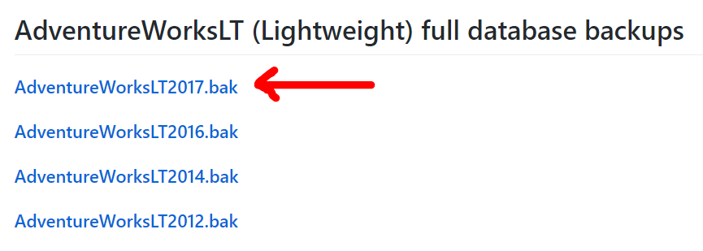

Open SQL Server Management Studio / Right-click at icon Databases / Restore Database…

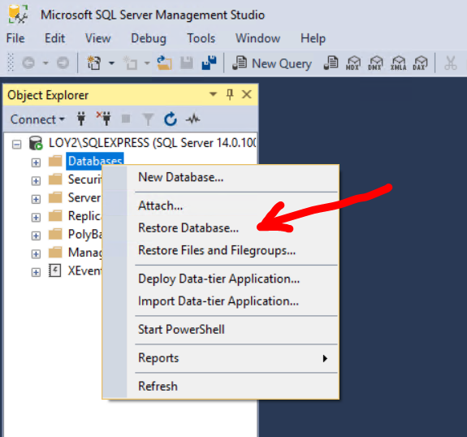

Click Device / Browse

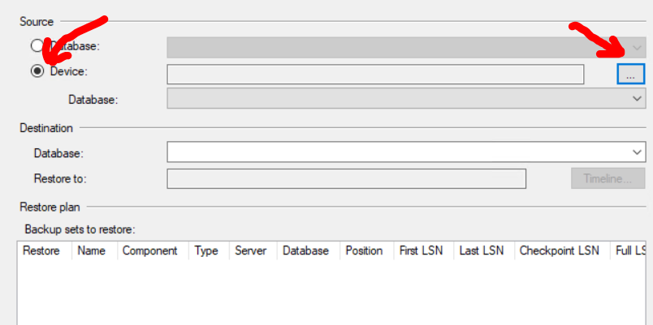

Click Add / Navigate to file / Click fileAdventureWorksLT2017.bak / press button OK

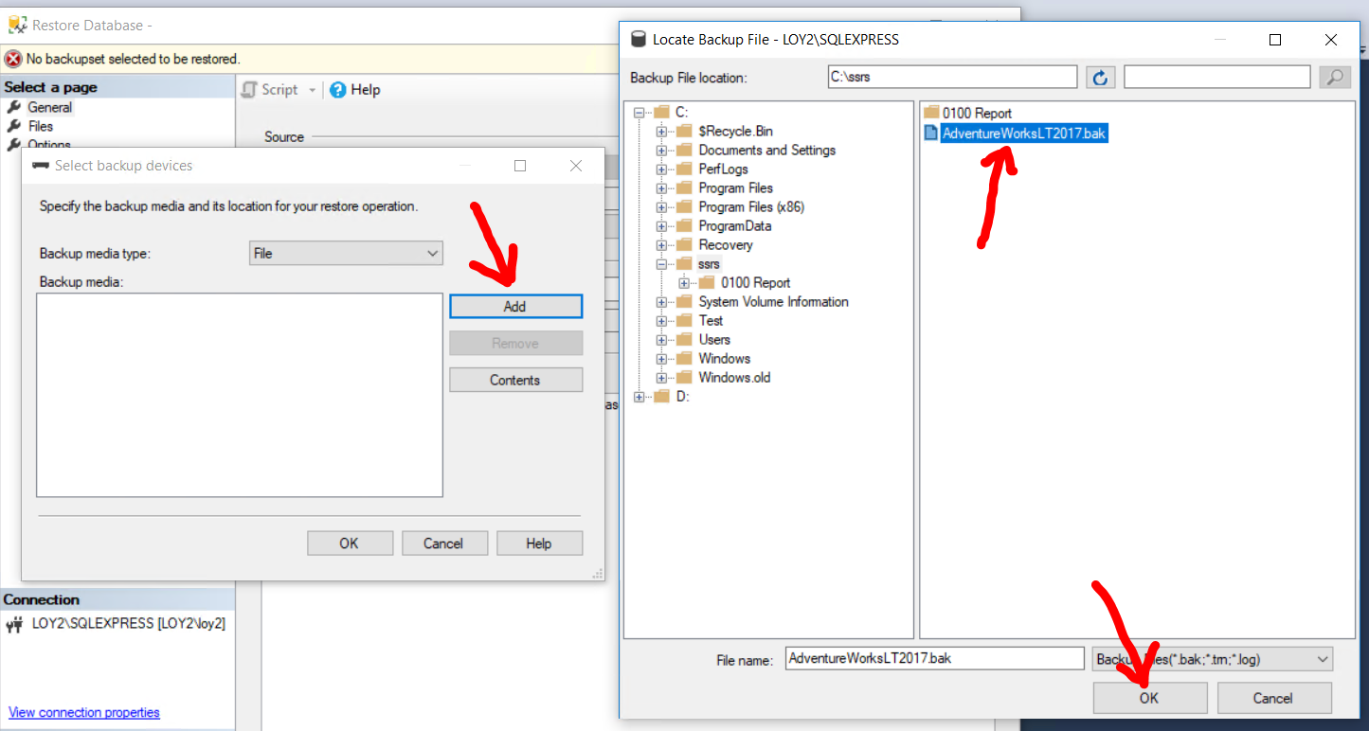

Make sure Backup media show .bak file / press OK

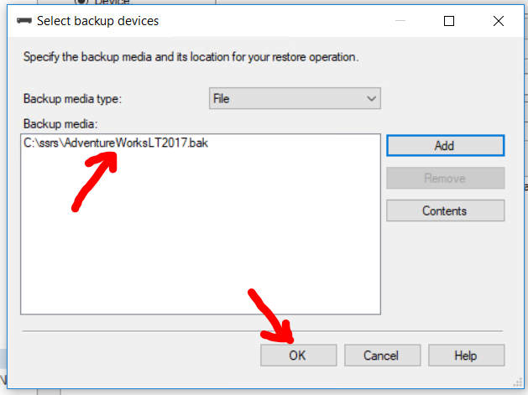

Press OK

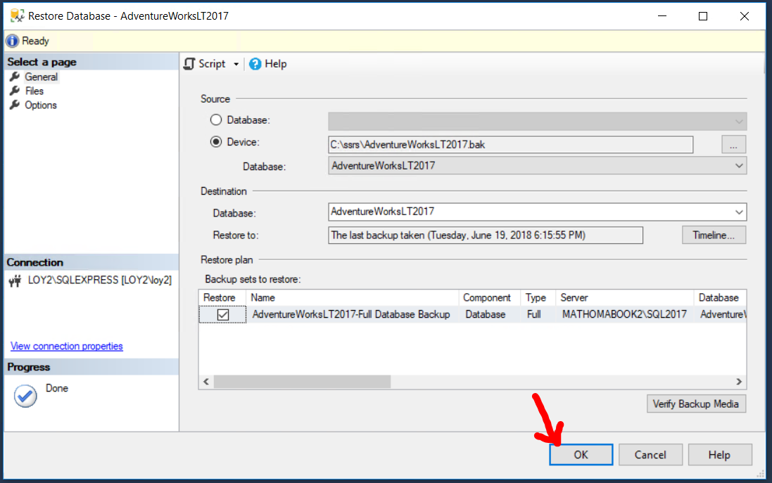

Success dialog shown / press OK

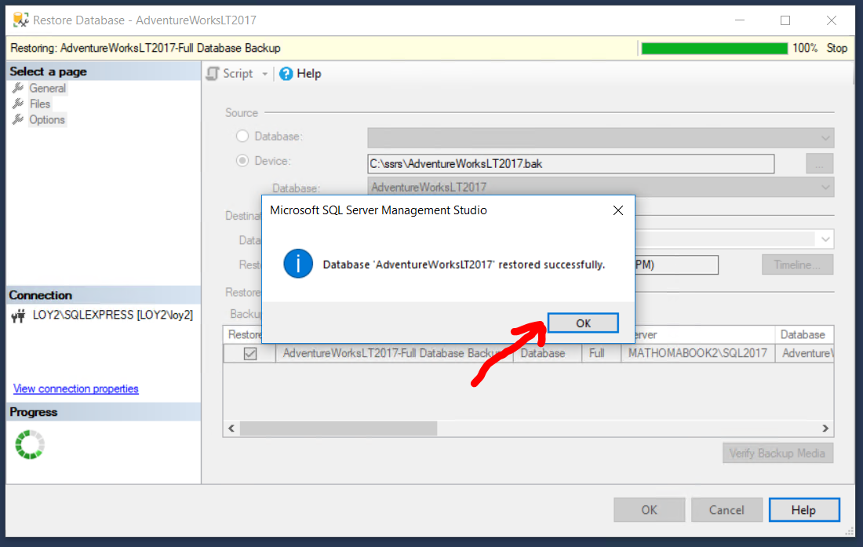

Look in Object Explorer to make sure you have all AdventureWorksLT2017 installed

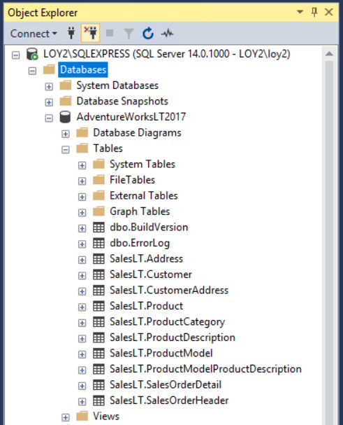

Query to 10 Rows from Customer table to make sure it’s good

